Allele: is one of two or more versions of DNA sequence (a single base or a segment) at a given genomic location. **VARIATION**

Gene: DNA sequences that contain the information needed to specify physical and biological traits (protein-coding or RNA genes). **FUNCTION**

Locus: is the specific physical location of a gene or other DNA sequence on a chromosome, like a genetic street address. **LOCATION**

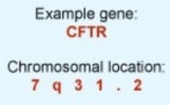

Haplotype: A haplotype refers to a set of DNA variants along a single chromosome that tend to be inherited together. They tend to be inherited together because they are close to each other on the chromosome. **COMBINATION**

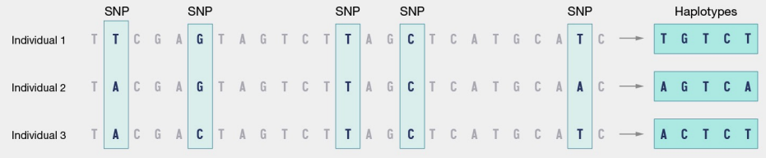

**FACTORS OF EVOLUTION**

We have mutation at a DNA level.

Natural selection, is the process were are selected the variants that better fits in the environment.

Gene flow, exchange of genetic material between different populations.

Genetic drift frequency of variants also varies due to random processes (gamete generation and migration).

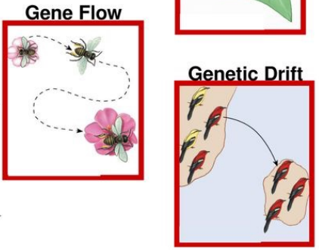

Mutations

Point mutations, small ones and they used to affect only a single nucleotide. They are the most frequent ones. We have 3 big types.

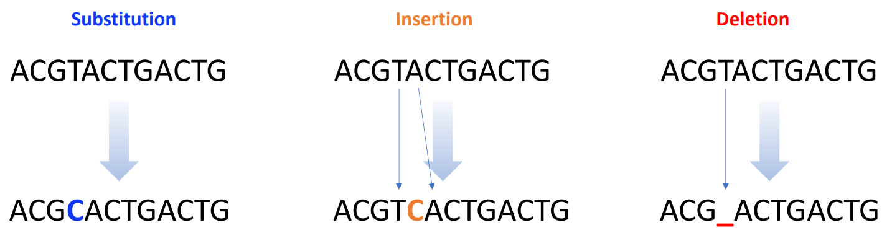

We can classify them by the nucleotide change and distinguish between transitions and transversions. Transitions are most frequent as the chemical change is less drastic.

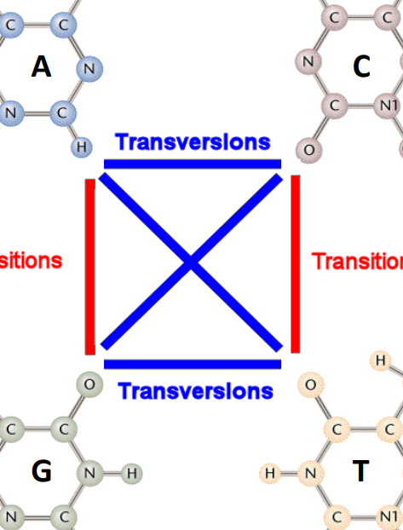 Purines (A and G) and pyrimidines (C and T).

Classified by Target Tissue

To be inherited they need to occur in the germline, somatic mutation affects just to the cell or tissue where they occur.

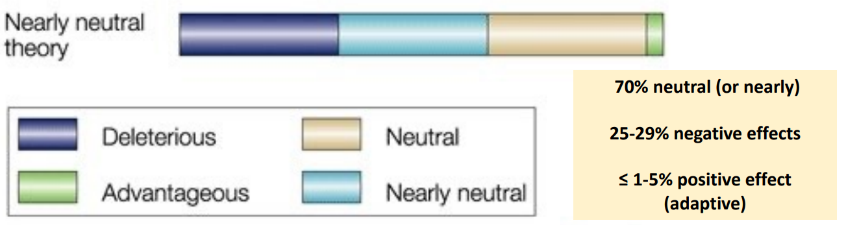

Mutations in genes

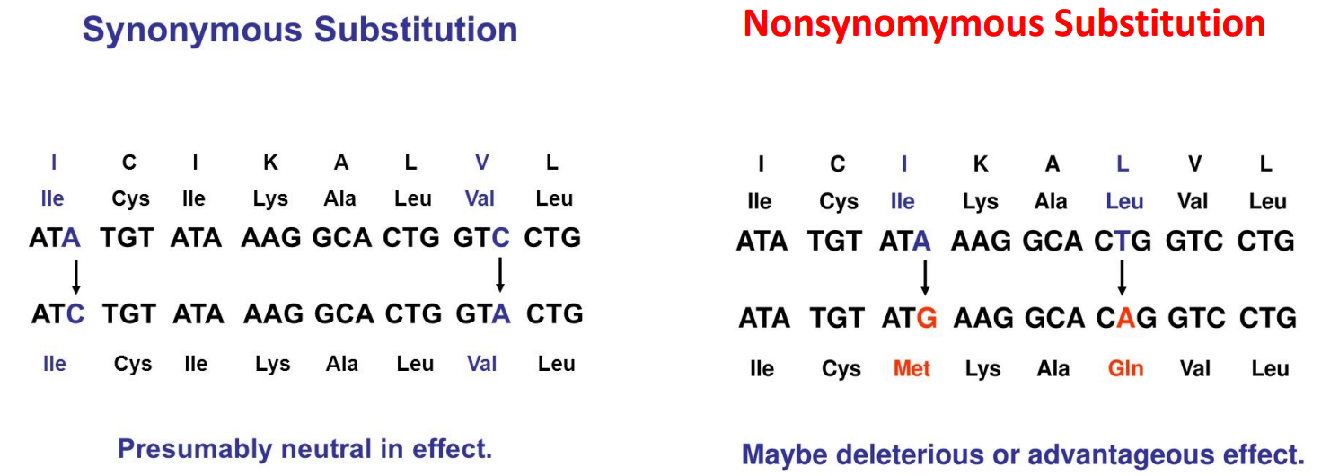

Frameshift ones

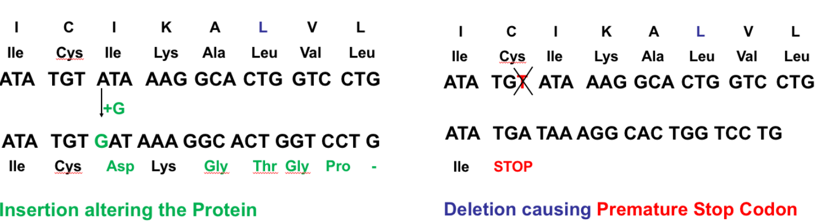

Other types of mutations

Less frequent than point mutations

• Involving several nucleotides

• Polymerase Slippage – microsatellites or SSRs

• Non homologous recombination – Inversions/Translocations

Single Nucleotide Polymorphisms (SNPs) <= 50bp in length

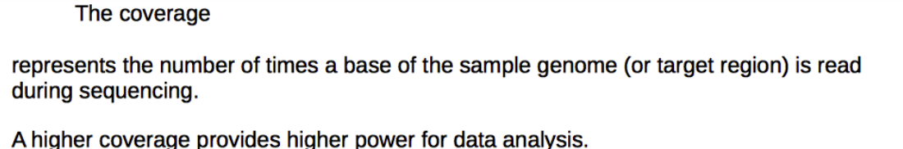

Base calling errors

Illumina Typically 0.05-0.1% of errors.

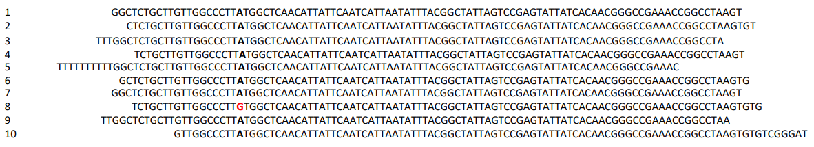

1/(10*100) error rate.

Sequence comparison

Genetic difference identified by comparison to a haploid reference.

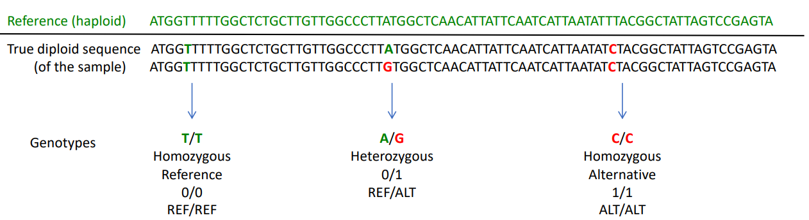

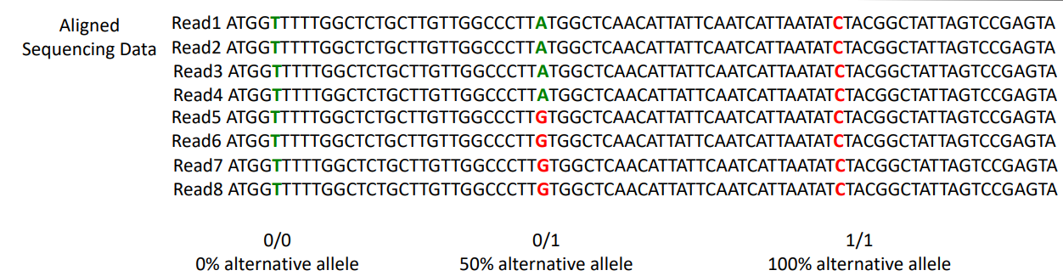

Compared to the green sequence.